Appendix 1

1,943 reports were gathered from 32 countries/regions by EPIWATCH® and selected for further analysis.
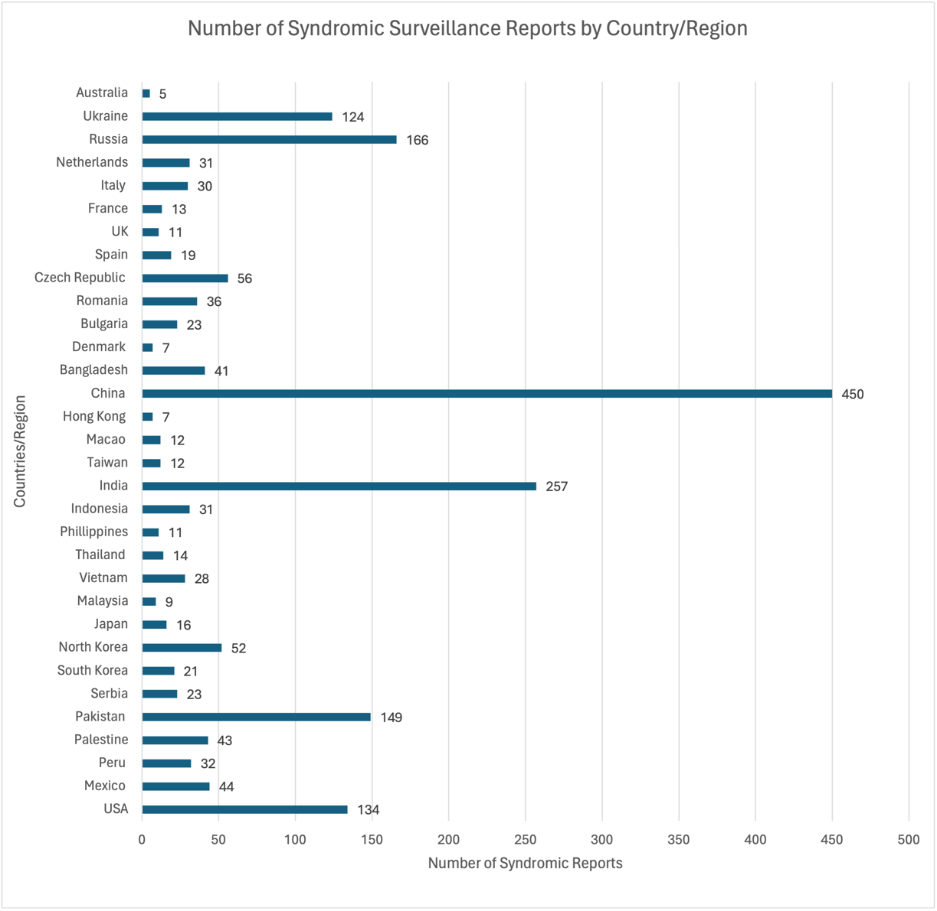
Figure 1. Number of Syndromic Surveillance Reports by Country or Region between 1 January 2023 and 11 February 2024

Early signals of the outbreak first surfaced in China around mid-August 2023. The frequency of reports started to increase in October 2023, and by November of the same year, there was a significant spike in reports within the EPIWATCH® system. Thailand had a noticeable upward trend in November 2023, which peaked in December. In India, Bangladesh, Indonesia, the Philippines, South Korea, and Japan, the trend started rising in October, reaching its zenith in December, and declining in January 2024. Moreover, Indonesia reported confirmed Mycoplasma pneumonia infections in December 2023.
Among Asian countries, Vietnam experienced a peak in cases in June, followed by another surge in December. In May and June of 2023, confirmed cases of MP were reported (Figure 2).

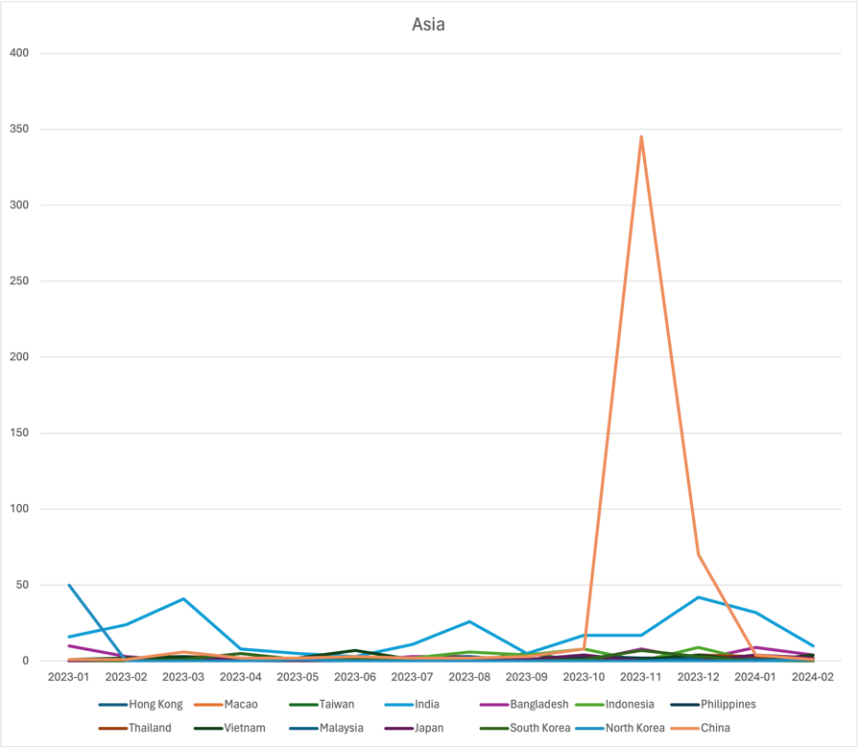
Figure 2. The Trends of Syndromic Surveillance in Asian Countries between 1 January 2023 and 11 February 2024

In December, countries in the Europe region experienced a significant increase in reports related to Mycoplasma pneumonia (Figure 3). Italy, Spain, and Denmark saw a sharp rise in cases during this month. Similarly, in the Netherlands, France, the Czech Republic, and Romania, the trend started to ascend in November, reached its zenith in December, and then began to decline. In Russia, confirmed cases of MP infection were reported on August 20, 2023, with a steady climb in trends from that point, reaching their highest point in December.

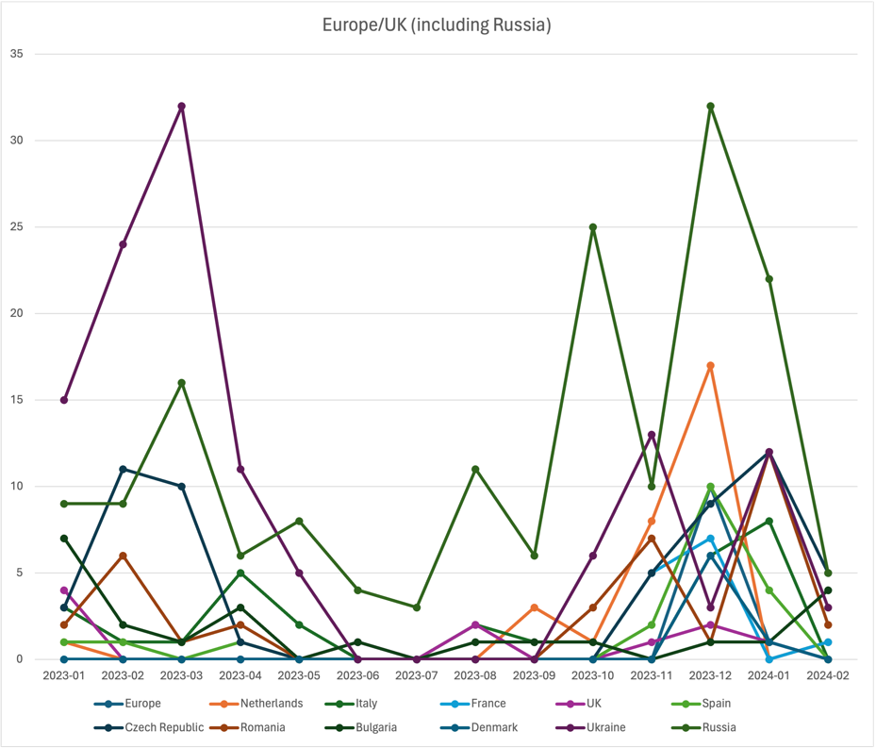
Figure 3. The Trends of Syndromic Surveillance in European Countries between 1 January 2023 and 11 February 2024

In the Americas region (Figure 4), Mexico saw its trend commence in October 2023, steadily climbing until December, and has since experienced a slight decline since February 2024. Conversely, in the USA, the trend began its ascent in October 2023, escalating significantly from November, reaching its peak in December, and subsequently declining in January 2024.
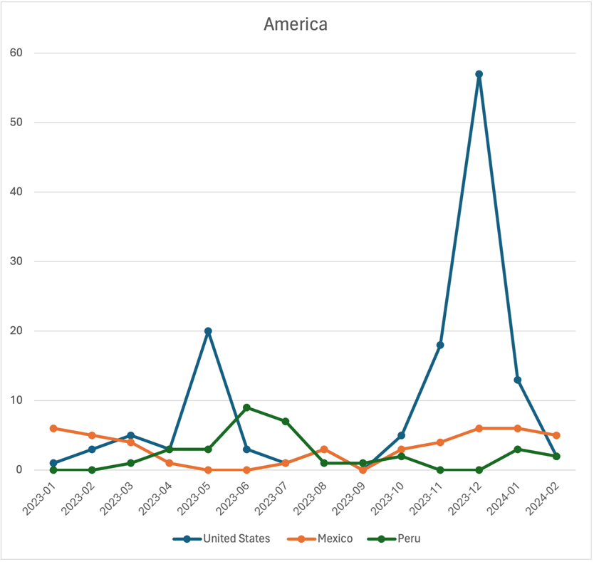
Figure 4. The Trends of Syndromic Surveillance in American Countries between 1 January 2023 and 11 February 2024

In Pakistan and Palestine (Figure 5), the trend began its ascent in November 2023, reaching its peak in January 2024 before gradually declining thereafter. Lastly, in Australia, a slight increase was observed in July 2023 (Figure 6).
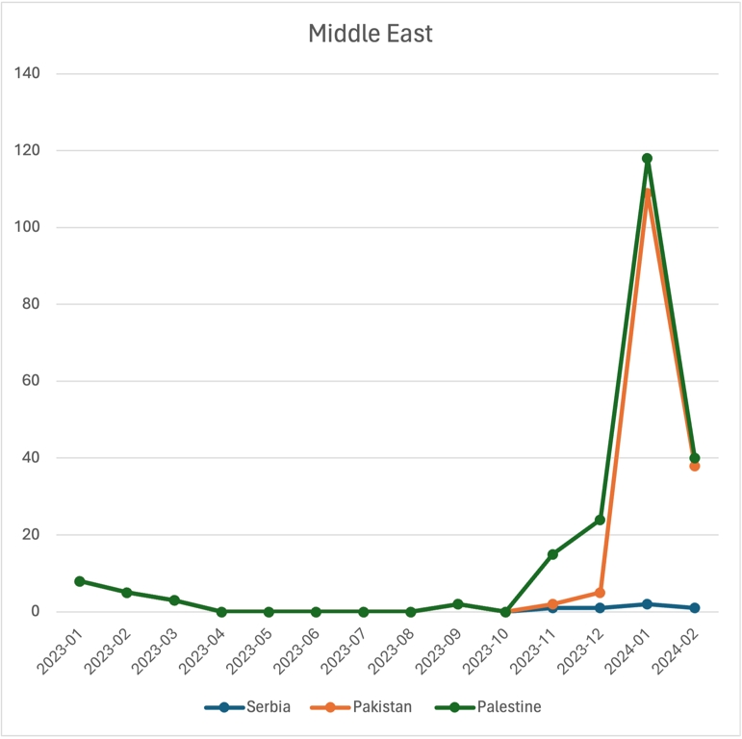
Figure 5. The Trends of Syndromic Surveillance in Middle Eastern Countries between 1 January 2023 and 11 February 2024

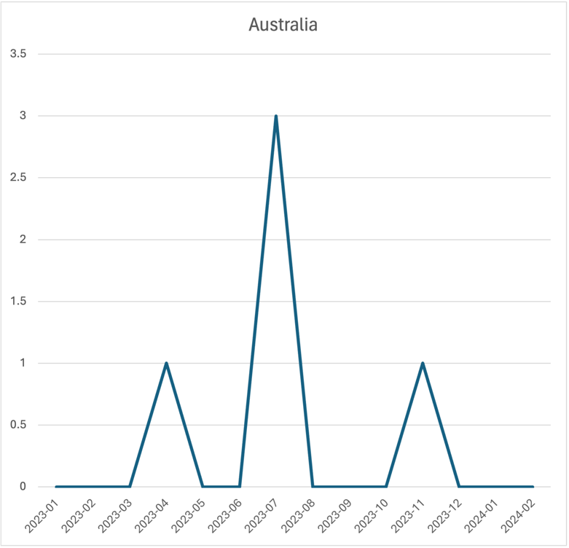
Figure 6. The Trend of Syndromic Surveillance in Australia between 1 January 2023 and 11 February 2024

